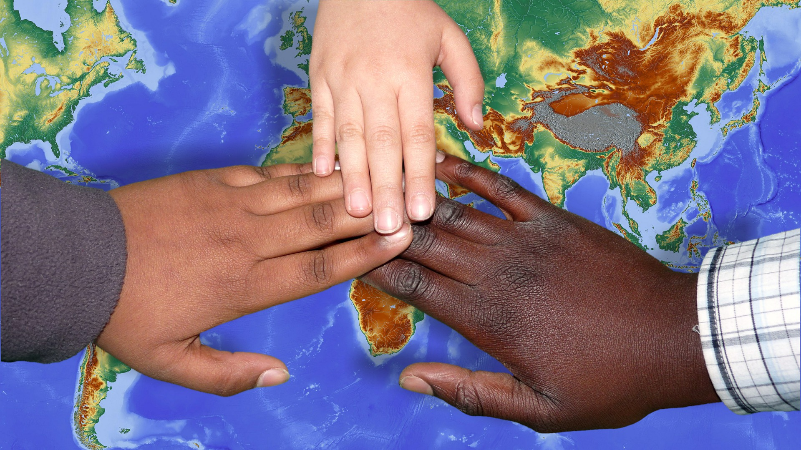

|  |
| --- |
| ANNUAL  REPORT  2017-2018 |
|  |
| aUGUST 21, 2018  FUTURE WORLD LEADERS  Authored by: Board of Directors |

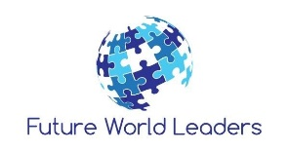

# TABLE OF CONTENTS

|  |
| --- |
| Message from the President and Vice-President……..…………………………………………………...3 Our Story………………………………………………………………………….....……………………………………….4 Mission and Vision………….......………………………………………………………………………….........…...5  How Future World Leaders is Making a Difference ……………………………………………............6 Meet the Board of Directors………………………………………………………………………………............7  Accomplishments To Date……….......……………………………………………………………………..……...9  Evaluation of 2017-2018……………………………………………………………………………………….......11  Testimonials.....................................................................................................................13  Goals for 2018-2019…….......………………………………………………………………………………..........14  Partners and Supporters……….......…………………………………………………………….….…….........15  How to Get Involved……………………………………………………………………………………………........16 |

# MESSAGE FROM THE PRESIDENT AND VICE PRESIDENT

# 

|  |
| --- |
| Youth in care (or receiving government services) are often portrayed in a negative light and placed in circumstances that restrict access to opportunities available to them. We aim to fill this gap in the current system. Future World Leaders marks a new era for youth-driven programs in Canada. More specifically, programs aimed at helping youth under government care.  Our program is built on 6 key components: Engagement, Education, Mentoring, Empowerment, Experiences, and Connections. Though each component is significant on its own, the combination fully encapsulates what it takes to become successful in life and in leadership.  The last year and a half has been filled with a roller coaster of emotions and struggles, yet more importantly many accomplishments; from initiating a pilot project in [2016-2017](tel:2016-2017) and embarking on our first humanitarian trip, to becoming a registered non-profit, creating a full year leadership curriculum, and then venturing on our second humanitarian trip.  We are proud of all that we have accomplished over this short time and look forward to continued development in the years to come.  *The Future World Leaders Team* |

# OUR STORY

|  |
| --- |
| "Never doubt that a small group of thoughtful, committed citizens can change the world, indeed, it is the only thing that ever has."  -Margaret Mead  Future World Leaders (FWL) is a non-profit organization devoted to empowering youth that are currently receiving services from the Department of Youth Protection (DYP). Our participant profile includes youth aged between 14 and 18 years old who are living with either their own families, in foster care, in a group home, in residential placement or transitioning to independent living, and receiving services at the time of application to the Future World Leaders program.   We empower the youth by fueling them with leadership tools and a life changing experience, while allowing them to immerse themselves in doing something greater for the less fortunate in communities abroad. |

# MISSION AND VISION

|  |
| --- |
| **OUR MISSION** To empower and inspire youth under government care, while making a difference across the world    Dominican Republic, Humanitarian trip, 2018  OUR VISION  To improve the outcome statistics of former youth in care across Canada |

# HOW FUTURE WORLD LEADERS IS MAKING A DIFFERENCE

|  |
| --- |
| We Engage our participating youth in our yearly leadership program; rich in Education, volunteer opportunities, fundraising, social justice, skill development, and Mentoring  C:\Users\Mama Power\AppData\Local\Microsoft\Windows\INetCache\Content.MSO\20CD0155.tmp  We Empower youth in care by providing them with the opportunity to partake in life changing Experiences, such as our annual humanitarian travels  C:\Users\Mama Power\AppData\Local\Microsoft\Windows\INetCache\Content.MSO\852ABB73.tmp |

We Connect our youth to the Montreal community; through attendance or participation in community events, supporting other local causes, volunteering, and guest speakers



We believe that our program will contribute to the *success* of these youths as they transition into adulthood; while also inspiring them to follow their dreams and want to help make a difference in their lives and the world (*leadership*).

[](https://www.google.com/url?sa=i&rct=j&q=&esrc=s&source=images&cd=&cad=rja&uact=8&ved=2ahUKEwj1ms6oqrXcAhVMT98KHeNbAQoQjRx6BAgBEAU&url=https://350.org/about/&psig=AOvVaw1TbXiGZRFeCK7V_Ud33t1A&ust=1532438912023981)

# MEET THE BOARD OF DIRECTORS

*Sussy Pamela Motta, Co-Founder & President*

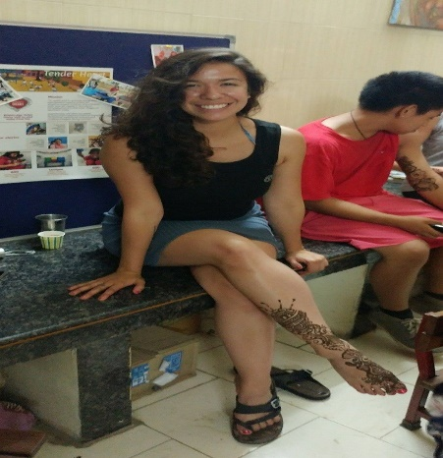

|  |
| --- |
| She is an Alumni of Care, and inspired by those experiences, Sussy pursued a DEC in Special Care Counselling at Vanier College; having graduated in 2010. In 2011, Sussy began her career as an Educator for Batshaw Youth and Family Centers, where she continues to passionately work towards empowering youth in care.   The combination of her own experiences in care and 7 years’ experience as an Educator in Youth Protection, Sussy recognized the limited resources available to youth in care relative to their peers, leaving them at a perpetual disadvantage. Sussy sought to find a solution to this problem by creating a program that could provide unique experiences and life changing opportunities to youth in care. Sussy initiated the Future World Leaders pilot project in 2016. The pilot project revolved around a humanitarian trip to India in collaboration with Macdonald High School. Based on the experience documented from the humanitarian trip they would then develop a leadership-humanitarian program similar to that of a local high school but one tailored to youth in care that would continue to offer youth in care with an empowering leadership-humanitarian opportunity. Thanks to all the parties involved, especially the incredibly talented and passionate organizers, the pilot project was a success. Shortly thereafter, Future World Leaders NPO was founded.   Sussy continues to pursue her vision of creating lasting change for youth in care; determined to build an everlasting contribution to the community in the form of Future World Leaders.   Fun facts about Sussy  •She is an avid yogi. She completed two yoga teacher certifications between 2011 and 2014.  •She loves being physically active, and is training, running, hiking, indoor rock climbing on a daily basis.  •Suz loves nature!  •Also loves to travel and discover new parts of the world. She loves learning through adventure.  •Is still pursuing her education for personal and professional development. She believes that learning keeps her young!  •Is a strong believer in listening to your heart and following your dreams. It keeps life exciting!  •Is happily married and a happy new mom *Carly Coxford, Co-Founder & Vice-President*   As a teenager I became interested in the idea of working in the field of child welfare because of some friends who were dealing with difficult family life experiences. A few of them spent time in group homes or got in trouble with the law and ended up in juvenile detention. I remember a friend of mine telling me a story about a worker he had, and how he felt that she helped him turn his life around. From that moment on I began to think about how amazing it would be if I could help make a difference in someone’s life, like that worker helped my friend. It took a while until I fully decided on my specific path, but in 2003 I went back to college to get my degree in Correctional Intervention. During my final year, I did an internship in Batshaw’s male youth detention center. I really enjoyed my experience there so decided to apply upon graduation.   I began working for Batshaw Youth and Family Centres as a recall educator in 2006. Throughout the first ten years, I gained valuable experience working in various positions; from an educator in the different group homes and residential units, a unit support worker offering aid to both staffs and youths during times of difficulty, and then as an after-hours assistant manager. During this time, I also went back to school; where I obtained a BA in Human Relations from Concordia University and a Masters in Social Work from McGill University. Since my graduation in the fall of 2016, I have been fortunate to add the title of social worker to my list of experiences.   I became involved in the Future World Leaders pilot project for a couple reasons: 1) After years of working in the field of youth protection, I witnessed all too many times the challenges and limitations facing both current and former youth in care, and wanted to do something to improve their chances for success; and 2) Helping others through humanitarian projects abroad had been a life goal of mine for years. Thus, I believed that through the project I would not only get to fulfill my own dreams but also get to share these life changing experiences with youth in care.   Though the pilot project’s humanitarian trip was an extremely impactful experience, after the trip I recognized that in order to truly effect long term change more needed to be done. So many youth age out of care without strong role models and with limited life skills. As such, we created a full leadership and humanitarian program that will help teach essential life and leadership skills, while also inspiring and empowering them to not only want to improve their own lives but to also want to make a difference in the world. |

# ACCOMPLISHMENTS TO DATE

|  |
| --- |
| Pilot Project 2016-2017   * A partnership with Macdonald High School’s leadership program was established * A pioneering team of Educators and Social Workers was formed (brought together by Sussy Pamela Motta); with the intention of documenting the experience of our humanitarian trip to India in the hopes of building a program inspired by Macdonald High school, but tailored to youth in care * We engaged two participating youth in care. The youth were involved in fundraising (including writing grant applications), team building activities, meetings with community leaders and cultural-educational outings * We ventured on our pilot project humanitarian trip to Tender Heart NGO in India * At the Tender Heart NGO, we contributed by paying for and building a walking path for the school and assisting in the various program offered. In addition to the humanitarian efforts, the trip included a cultural immersion component; comprised of an Indian welcome ceremony, outings (to the Taj Mahal, Lotus temple, Yoga ashram & Aarti experience), a cultural exchange with a High School in Faridabad, and a snake charming performance * The program proved to be successful, as both participants expressed that the program had a positive impact in their lives. One of the two youth even asked to continue participating with us for the 2017-2018 year * A third youth was engaged in our pilot project through an avenue separate from the regular program. After having expressed wanting to somehow be involved and showing an interest in media, we connected him with the Digital Literacy Project at the Atwater Library where he worked throughout the summer developing a video for Future World Leaders documenting the humanitarian trip. The youth was also later offered a job with the Digital Literacy Project for the summer of 2018   Future World Leaders 2017-2018   * Registered as a Non-Profit Organization in Quebec * Our yearly leadership curriculum was developed and implemented (spearheaded by Carly Coxford) * From October to June, the youth attended bi-weekly leadership sessions, volunteered in the community, partook in inspiring events such as ‘We Day’, met with community leaders and former youth in care, supported other community causes such as ‘The Bell’ Fund, and organized fundraising events * We successfully launched our second humanitarian trip; this time to the Dominican Republic * In the Dominican Republic, in collaboration with Pasos de Esperanza DR, we contributed to building two homes for two families in need * At the start of the 2017-2018 program, we had quadrupled our youth participants. Even after attrition throughout the year, we were still left with a 50% increase from the 2016-2017 year * The returning youth from the 2016-2017 year continued to show growth. Since his enrollment with Future World Leaders, he has taken school more seriously, pursued personal goals like getting his driver license, has more positive connections in the community, and has expressed that this program helps him stay out of trouble while doing something he likes to do; helping others. He has also expressed that this program is in line with his future goals, as he hopes to one day return to Inukjuak and help shape his community into a better place to live. Given his incredible growth and commitment, he will become our first ever youth mentor in the upcoming 2018-2019 program * During a program session connecting our youth to other community leaders, one of our participants was able to meet the Vice-President of Youth in Care Canada. Through this connection, the participant was informed of and encouraged to apply for eligible scholarships. The youth subsequently applied and was recently awarded a $3,000 renewable scholarship |

# EVALUATION OF 2017-2018

# PROGRAM

# *Curriculum:*

# 50% of the participants said that they felt the program would be better/more impactful if sessions were weekly

# All the participants said they were pleased with the content of the curriculum and found it to be useful information, yet 50% said they would have liked to learn more about certain topics

# 75% of the participants reported that the opportunities given to practice their leadership skills was ‘as expected’, whereas 25% reported they were only ‘somewhat’ given the opportunity

# *Communications:*

# All the participants were satisfied with the program coordinators communications (i.e. to inform of changes & updates, and answer questions)

# throughout the year; with 50% reporting it to be ‘as expected’ and 50% ‘better than expected’

# 100% of the surveys received from the youth’s family or workers described the program coordinators communications with them throughout the year as

# ‘outstanding’, and said that the coordinators were easy to reach, quick to respond, respectful and informative, and organized

# *Connections:*

# 75% of the participants said the connections they made with the other participants were ‘better than expected’

# 50% of the participants said the connections they made with the coordinators of the program were ‘better than expected’, and the other 50% were ‘as expected’

# An area that was not as strong was the connections made in the community; with 50% saying they made connections ‘better than expected’, 25% ‘as expected’, and 25% not at all

# Of all the connections made, 75% felt the connections can help them with their future goals yet only 50% of the participants found these connections to be

# useful to them in other areas of their current lives (i.e. at school, home, with friends, etc.)

# TRIP

# *Humanitarian work:*

# All the participants found the humanitarian work to be rewarding; with 75% reporting it to have been ‘better than expected’ and 25% ‘as expected’

# *Cultural Immersion:*

# When asked how well they learnt about a new culture (i.e. food, language, lifestyle, economy), 50% said ‘as expected’, 25% stated ‘better than expected’, and 25% only ‘somewhat’

# OUTCOMES

# 75% of the participants described that the experience made a difference in their current life, and 100% said the experience will help them in the future

# 100% of the surveys received from the youth’s family or workers specified feeling that the program had a positive impact in the youth’s life

# 100% of the participants as well as the youth’s family or workers said they would recommend the program to others

# 100% of the participants said they are interested in staying involved with FWL

# The youths’ responses to what the most valuable thing they got out of the program included:

# Travel experience

# Exposure to a new culture

# Connections made

# Being able to help people

# Learning about themselves

# “Loved it all”

# TESTIMONIALS

“This program was an eye opener. It gave me a way of thinking that I did not know I had. This program is a life changing opportunity that everyone should take”

* Youth, 16

“My humanitarian trip to the Dominican Republic was the most amazing experience of my life. It really put things into perspective for me. As wealthy teens we sometimes forget how lucky we really are to be living in a home with a roof over our heads & unlimited water. Before this trip I was so caught up in drama that I forgot there’s bigger problems in the world. Seeing them first hand made me really think. I am forever grateful I got the opportunity to meet new people & go on this trip. I built connections with such amazing people there. Everyone is so full of love & to say that I might have the opportunity to do this again is a blessing. Much love to everyone”

* Youth, 15

“I learned so much from the trip once again. I learned not to take things for granted, that everything I got is precious, made connections with people, learned about myself more and about different cultures and country. I personally would recommend this group to whoever wants to discover the world but discover themselves as well. This group helped me a lot. Hope to continue again”

* Youth, 17

“We would like to thank you for giving …. the opportunity to be part of this unique experience.  I am sure he has walked away from this experience with not only a broader knowledge base but also a greater awareness of his empathic abilities. We look forward to another collaboration in the near future”

- Group home manager

“Ce programme fait une différence significative dans la vie d’un jeune qui a la volanté de découvrir l’autre, de contribuer à une autre communauté que la sienne et de partager d’autres visions et ses et coutumes. Il ouvre des horizons permet l’auto-accomplissement et de par les réalités découvertes, rend le jeune plus concient de ce qu’il peut apporter et partager. Il apprend l’espoir a travers les difficultés et apprècie d’avantage son propre milieu de vie. Découvrir l’humanité permet de découvrir son propre humanisme, ses forces et ses points d’amélioration. La découverte devient un fier apprentissage et apporte la confiance”

- Youth’s family member

# GOALS FOR 2018-2019

|  |
| --- |
| * To increase our number of participants * Implement our new revised and enriched yearly leadership curriculum * Continue connecting our youth with the community through more volunteer opportunities, meetings with community leaders, and introducing them to other helpful resources * Launch our third annual humanitarian trip; with this year’s focus being to organize a Canadian trip that will offer volunteer support to a native reserve * To improve upon the cultural immersion aspect, this year will include more cultural and historical learning experiences both prior to and during the trip   Timeline   * August 27 – September 4: Info sessions/Recruiting period * September 14: Youth application deadline * Week of September 17-21: Review applications and book interviews * Week of September 24-28: Interview youth candidates * October to June: Leadership/Humanitarian program * June to July: Humanitarian trip |

# PARTNERS AND SUPPORTERS

|  |  |
| --- | --- |
| |  | | --- | | Partners   * Christopher Martin-Chang, Macdonald High School Leadership class (2016-2018) * Centre Intégré Universitaire de Santé et de Services Sociaux de l’Ouest-de-l’Île-de-Montréal (2017-present)   Community & Organization Supporters   * Sterling Downey, City Councilor of Verdun, Montreal * Revline Fitness, St Henri * Shakti Rock Gym   Individual Supporters   * All our friends, families and other community members who believe in us   *THANK YOU!!!* | |

# HOW TO GET INVOLVED

|  |
| --- |
| Make a Donation   * GoFundMe page <https://www.gofundme.com/futureworldleadersnpo> * Come to our upcoming fundraising events * We accept e-transfers at info@futureworldleaderscanada.org   C:\Users\Mama Power\AppData\Local\Microsoft\Windows\INetCache\Content.MSO\CBFD208C.tmp |

[](https://www.google.com/imgres?imgurl=http://careers1foodgroup.azurewebsites.net/wp-content/uploads/2016/11/Join-Our-Team-Yellow-e1481650902651.png&imgrefurl=http://www.ssacareers.com/apply-now/&docid=W2SSGIoCsFbyKM&tbnid=GkEEvnq7C41uyM:&vet=10ahUKEwi654670_HcAhXGuFkKHXOeCPEQMwhwKC8wLw..i&w=675&h=578&bih=603&biw=1280&q=join%20our%20team%20icon&ved=0ahUKEwi654670_HcAhXGuFkKHXOeCPEQMwhwKC8wLw&iact=mrc&uact=8)

Visit our website at [www.futureworldleaderscanada.org](http://www.futureworldleaderscanada.org) to find out about different volunteer opportunities available

[](https://www.google.com/imgres?imgurl=https://blogs.egu.eu/geolog/files/2015/09/Spread-the-word.jpg&imgrefurl=https://blogs.egu.eu/geolog/tag/convening/&docid=W-qxGrq0XvgPvM&tbnid=nAOMm8cIzk4Y3M:&vet=10ahUKEwix7PWY0_HcAhVCjlkKHT-vAp4QMwhwKDYwNg..i&w=500&h=501&bih=603&biw=1280&q=spread%20the%20word&ved=0ahUKEwix7PWY0_HcAhVCjlkKHT-vAp4QMwhwKDYwNg&iact=mrc&uact=8)

Follow us on social media (Facebook & Instagram). Stay tuned for Future World Leaders updates, share and like our pages

Help us spread the word (of our story, who we are, and what we do).